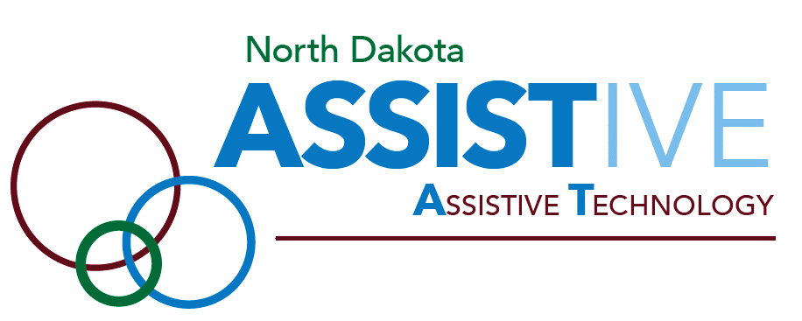

POSSIBILITIES GRANT APPLICATION

Applications will be reviewed weekly.
Incomplete applications will not be considered.
Questions? Please call: 1.800.895.4728

GRANT APPLICATION CHECKLIST
Make certain to complete the grant application in its entirety. Every section must be completed. Applications that are incomplete or missing required supporting documents will NOT be accepted. Before submitting the application, use the following checklist:
☐ Background Information (Pg. 4)
- Provide a good description and detail of your medical condition or disability.
- Be specific. Your answer helps the review committee understand the need for assistive technology.
☐ Grant Request (Pg. 5)
- NOTE: Possibilities Grant dollars cannot be used to pay for devices or services purchased prior to approval of your application.
- Be as specific as possible on the device(s) and/or services being requested.
- Information must include the vendor name and/or where the assistive technology can be purchased.
- A dollar amount requested or cost of the device must be included.
- Provide/attach any other supporting documentation (assessments, evaluations, etc.) from consultants or specialists recommending this device if available.
☐ Funding History (Pg. 6)
- It is important that all potential forms of funding for AT have been investigated and explored before applying. Review your private health, Medicare and Medicaid insurance policies to determine what assistive technology or durable medical equipment coverage is provided.
- Provide copy of denial letters (if applicable) from insurance/health coverage.
☐ Eligibility Criteria (Pg. 7)
- Attach a copy of the most recent federal tax return form: 1040, 1040A or 1040EZ.
- If you are not required to file for the past year, you must provide a copy of Social Security Benefits letter or annual income.
☐ Signature (Pg. 9)
- Required signature of application to verify that all application information provided is true and complete and also gives consent to use publicity material about your award.
- Without dated signature, the application will not be considered complete and eligible for review.

Please Note:
The Possibilities Grant is a last resort funding program, meaning all other funding sources must be used before an applicant will be considered. It also means if a certain entity is required to pay for AT, this program will not cover it. For example, AT required by law to be purchased by a school will not be funded by this grant. In addition, augmentative and alternative communication (AAC) devices will not be funded as well as they are paid for by most insurances; this includes tablets with AAC apps for communication purposes.

To be eligible, your total family/household income must fall under the guidelines listed in the table below:

Applicant Income Guidelines for
January 1, 2023 to December 31, 2023

# of Persons in  Household* | Gross  income
1 | $58,320
2 | $78,880
3 | $99,440
4 | $120,000
5 | $140,560
6 | $161,120

Because of this program’s limited funds, hearing aids will not be considered. We will however consider alternative hearing devices such as the Pocket Talker or Comfort Duett. For more information, please contact our office at 1.800.895.4728 and ask to speak to one of our consultants.

While there is no cap set on the amount that may be requested, but it is expected awards will not exceed $2,000. As public or private funds may only cover a portion of assistive technology costs, Possibilities Grant funds can be used in partnership to close that gap.

GRANT APPLICATION FORM

Incomplete applications will not be considered.

Questions? Please call: 1.800.895.4728

CONTACT INFORMATION

Applicant
Name: ________________________________________________________________

Address: ______________________________________________________________

City: _____________________________ State: _____________ Zip: ______________

Mailing Address (if different): ______________________________________________

County: __________________________ Date of Birth: _________________________

Phone: Home___________________________ Work __________________________

E-mail address: _________________________________________________________

Living Arrangement (Own home, nursing facility, other-specify): _________________________

______________________________________________________________________

Note: Please include the following if completing the application for the person above.
Name: ________________________________________________________________

Title/Relationship to Applicant: _____________________________________________

Address: ______________________________________________________________

City: _____________________________ State: _____________ Zip: ______________

Mailing Address (if different): ______________________________________________

Phone: Home __________________________ Work ___________________________

E-mail address: _________________________________________________________

BACKGROUND INFORMATION

Describe your disability to include diagnosis, severity, prognosis, and functional limitations.
Try to paint a picture of yourself to help us understand what your disability is, how long you have had it, if it is temporary or permanent, and how it impacts your day-to-day activities. (Please be specific.)
______________________________________________________________________

______________________________________________________________________

______________________________________________________________________

______________________________________________________________________

______________________________________________________________________

______________________________________________________________________

______________________________________________________________________

______________________________________________________________________

Are you currently working with ND Assistive staff?
No _____ Yes (Name) __________________________________________________

Is there a Healthcare Professional who could verify your disability?
(i.e. licensed physician, audiologist, teacher, speech language pathologist, physical therapist, occupational therapist, home health, etc.)

Name: ____________________________________ Title: _______________________

Phone: _________________________ E-Mail: ________________________________

Name: ____________________________________ Title: _______________________

Phone: _________________________ E-Mail: ________________________________

Name: ____________________________________ Title: _______________________

Phone: _________________________ E-Mail: ________________________________

EQUIPMENT AND/OR TRAINING REQUESTED
Include/attach vendor information, a product description, and estimated cost. (Please be specific.)
NOTE: Possibilities Grant dollars cannot be used to pay for devices or services purchased prior to approval of your application.

Device Vendor Information Estimated Cost

______________________________________________________________________

______________________________________________________________________

______________________________________________________________________

______________________________________________________________________

Do you think you will need training to successfully use the device(s) requested?
Yes _____ No _____

Where do you plan on using this device(s) (i.e. school, home, work, etc.)?

______________________________________________________________________

How did you determine what assistive technology was appropriate?
______________________________________________________________________
______________________________________________________________________
______________________________________________________________________

Did you have a formal evaluation? Yes ______ No ______
If yes, please list who with. _______________________________________________
______________________________________________________________________

Did you try out the requested assistive technology for a period of time or participate in a product demonstration? Yes ______ No ______
If yes, please explain. __________________________________________________
_____________________________________________________________________
_____________________________________________________________________
_____________________________________________________________________
NOTE: If you have not had a formal evaluation or a product demonstration, please contact us at 1.800.895.4728 to schedule one. Priority will be given to those who have worked with one of our ND Assistive Technology Consultants.
Explain why this device increases your independence on a day-to-day basis. (Please be specific.)
______________________________________________________________________

______________________________________________________________________

______________________________________________________________________

______________________________________________________________________

______________________________________________________________________

FUNDING HISTORY
NOTE: As a reminder, this is a last resort funding program (see Grant Application Checklist for further explanation).

Have you received a Possibilities Grant in the past? Yes _____ No _____

Have you approached any other funding sources before seeking help from this program? (i.e. Workforce Safety and Insurance, a Medicaid Waiver, the Public School System, Vocational Rehabilitation, the Great American Bike Race, North Dakota Association for the Disabled, etc.) Yes _____ No _____
Please explain: ______________________________________________________________________
______________________________________________________________________
What Medical insurance do you currently have? (i.e. private insurance, Medicare, Medicaid, Medicaid Waivers, Workers Compensation, Veterans Administration, etc.)
______________________________________________________________________
______________________________________________________________________
______________________________________________________________________

Is the assistive technology you are requesting funding for covered by your insurance? Yes ______ No ______

If “No”, please send a copy of your denial letter.
Assistive technology funding can sometimes be confusing. If you are unsure if your request is appropriate for the Possibilities Grant, please call us at 1.800.895.4728. We are happy to help you explore and understand your assistive technology funding options.
Describe any financial circumstances that make the purchase of the requested assistive technology difficult. Although information about assets is not requested, those monthly or routine expenses related to disability that create financial hardship should be mentioned.

______________________________________________________________________

______________________________________________________________________

______________________________________________________________________

______________________________________________________________________

______________________________________________________________________

______________________________________________________________________

______________________________________________________________________

Required Income Documentation
In order to be eligible for the program
**Your return will be compared to the table below for eligibility**
Applicant Income Guidelines for
January 1, 2023 to December 31, 2023

# of Persons in  Household* | Gross  income
1 | $58,320
2 | $78,880
3 | $99,440
4 | $120,000
5 | $140,560
6 | $161,120

Do you file Federal income taxes? Yes____ No____
If YES, you must provide a copy of last year’s Federal IRS 1040 tax form(s) filed by you and members of your family/household.
If NO, to confirm your income eligibility, please mail or fax documentation that proves one of the following:
Evidence of your total family/household income, such as recent Social Security Administration retirement benefit statement(s) or other pension benefit statement(s).

For the purpose of determining eligibility for the Possibilities Grant program, ND Assistive defines “income” and “household” as follows:
“Income” is all income actually received by all members of a household. This includes salary before deductions for taxes, public assistance benefits, social security payments, pensions, unemployment compensation, veteran's benefits, inheritances, alimony, child support payments, worker's compensation benefits, gifts, lottery winnings, and the like. The only exceptions are student financial aid, military housing and cost-of-living allowances, irregular income from occasional small jobs such as baby-sitting or lawn mowing, and the like.
A “household” is any individual or group of individuals who are living together at the same address as one economic unit. A household may include related and unrelated persons. An “economic unit” consists of all adult individuals contributing to and sharing in the income and expenses of a household. An adult is any person eighteen years or older. If an adult has no or minimal income, and lives with someone who provides financial support to him/her, both people shall be considered part of the same household. Children under the age of eighteen living with their parents or guardians are considered to be part of the same household as their parents or guardians.

Responsibilities and Consent Signature(s)

I agree to provide ND Assistive with my story and pictures of myself using the device(s) purchased with Possibilities Grant award funds. INITIALS: ______

My signature below gives ND Assistive permission to use my name, likeness, image, voice, and/or appearance as such may be embodied in any pictures, photos, video recordings, audiotapes, digital images, stories, and the like, taken or made on behalf of my involvement with ND Assistive activities. INITIALS: ______

The information I have provided on this application is true and complete to the best of my knowledge. If under 18 years old or under guardianship, both applicant and parent/guardian must sign. INITIALS: ______

I understand incomplete applications will not be considered. INITIALS: ______

_______________________________________________ __________________
(Applicant Signature) (Date)

_______________________________________________ __________________
(Parent/Guardian Signature, if applicable) (Date)

Your completed application may be sent to one of the following:

Mail:
ND Assistive
Possibilities Grant
3240 15th Street South, Suite B
Fargo, ND 58104

Fax:
701.365.6242

Email:
pposey@ndassistive.org

Questions? Please call: 1.800.895.4728

